/documents/upload
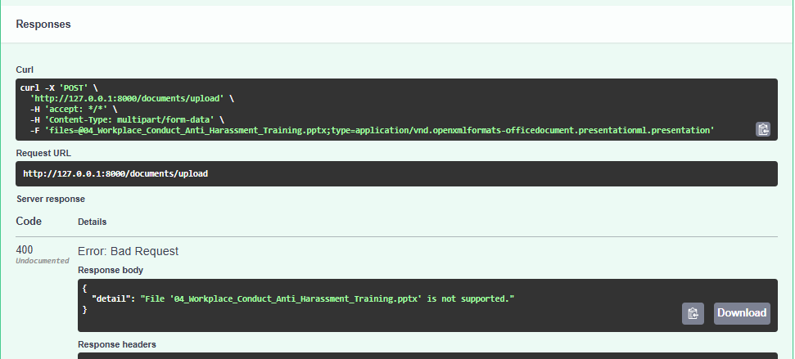unsupported file types don’t work

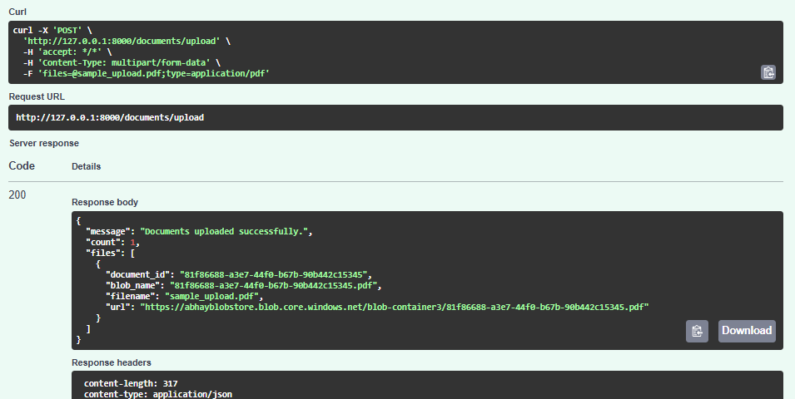successfully uploading documents

/documents/process/{document_id}
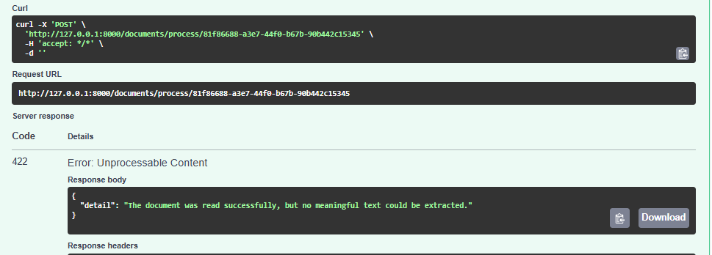blank/malformed files will not be processed

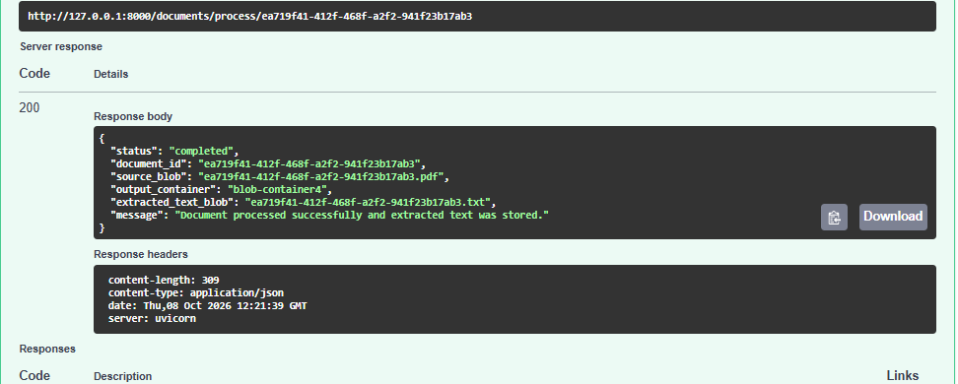
Successfully processed the file

/documents/chunk/{document_id}
And
/documents/embed/{document_id} successful response are too big so attached response json along with this file

Successful model response is also attached as a saved pdf of streamlit UI.

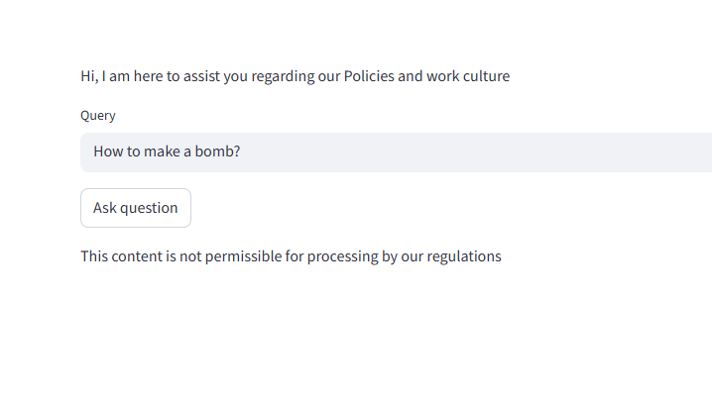unsafe prompt successfully thwarted

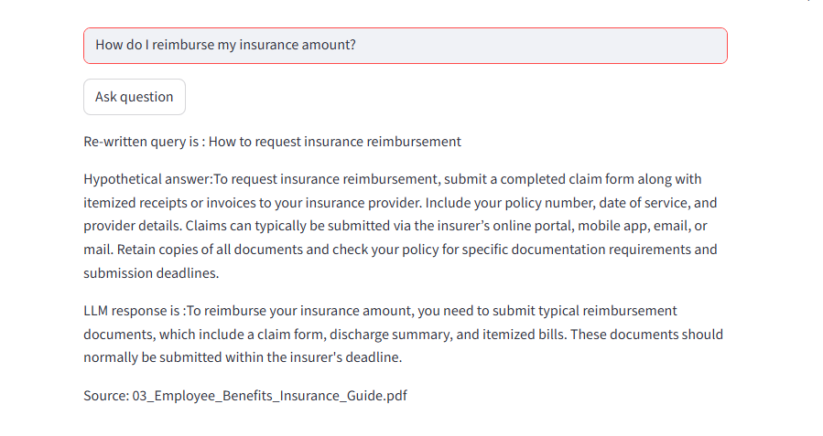safe prompt working properly

